How to install aaBridge on a Mac 2024 edition
Roger Pfister

I am the author of aaBridge, a Java app (program) that does great things for Bridge players. Recently because of the efforts of BBO bridge teacher, Karen10 it has received much new interest. aaBridge runs on Windows, Linux and Mac’s.
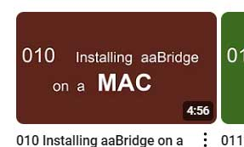
Bridge player CarlieG has kindly sent me the procedure (with graphics) for getting aaBridge to run on her ‘M Chip’ Mac running macOS Sonoma. Of course it will also work on older Intel Macs.
These instructions extend and update the still useful video about installing on a Mac, which is on YouTube at . . .
https://www.youtube.com/@aaBridge

The first version of this document (which follows as an appendix to this doc) may also be useful.

Step A - Download and install Oracle Version 8 java for INTEL

This is best got from Oracle at https://www.java.com/en/download/manual.jsp

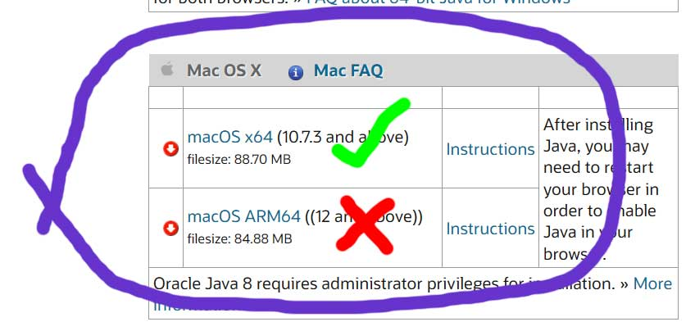
You need the Intel Java 8 even if you have an ‘M chip’ Mac because one of the key features in aaBridge is the Double Dummy Solver DDS (you will want it) and this needs the Intel Java. And because of Apple magic the Intel Java runs fine with the M chip Macs.

As this is installing normal software for the Mac I will not go into additional detail.
Step B - Download the aaBridge .jar file

1. Go to the aaBridge website
https://sites.google.com/view/rogerpf-com/aaBridge
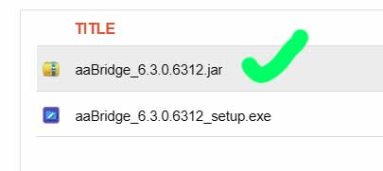
2. Click on the jar’s filename, here -
aaBridge_63.0.6312.jar

3. You get the below “No Preview available” message.


4. Click on Download. There is a long wait (about a minute). Be patient.

5. You will get the message that Google Drive can’t scan this file for viruses.
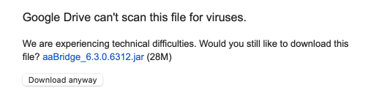

6. Click on “Download anyway”

Another long wait.
7. Open your Downloads folder.
You should see the aaBridge….jar your have just downloaded

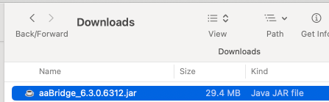

Step C - Tell macOS you want to run it

1. You MUST CONTROL CLICK on that aaBridge .jar file
i.e. hold the CONTROL KEY down while you click as normal.
(You may if you wish move the file somewhere else, first.)
If you just ‘click' it you get this message that says - it cannot be opened.
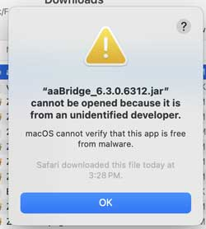

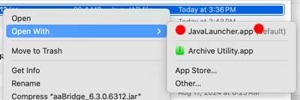
When you CONTROL CLICK the file, a menu will show

2. Select - Open With

3. Click on JavaLauncher.app (red dots)

4. You get a warning asking if you are sure you want to open it.

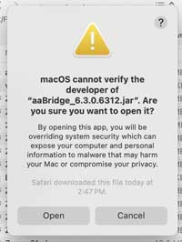

5 Click - Open - and that should open aaBridge.

In future - you should NOT need to hold down the CONTROL key to get to
JavaLauncher.app option and on many systems just double clicking on the jar will run it.

This is why many users copy the aaBridge .jar file to their Mac desktop and just double click the icon to run it.
If you MOVE the jar file you may need to repeat the CONTROL Key procedure.

What if aaBridge still won’t run

Yes things change and future versions of MacOS may have more hoops that users like you need to jump through to get aaBridge running. [sigh].

Well you can contract Karen or me roger.pfister@gmail.com
Neither of us have a Mac but the one thing we can do is to ask more technical Mac users if they know of away around your problem.

What if you are or know some one who is a MORE TECHNICAL Mac user ?

Or what if you would like to try to find a solution to your problem ?

On the next page I have summarised the resources that Mac users can use when trying to find out how to run (on a Mac) a standard .jar file downloaded from the web, like aaBridge.

If you do have problems and the FIND the solution ☺ It would be really if you could forward the details to me and . . .
I will put the info into the next release of THIS document. - Many thanks.
(FYI - The latest version of this doc is available on the aaBridge website.)

https://sites.google.com/view/rogerpf-com/aaBridge

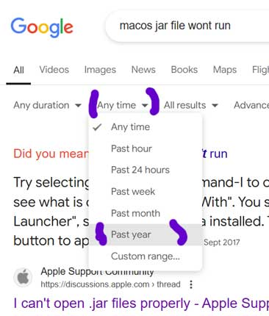
Hunting for a solution

Try – googling queries like
macos jar file wont run virus

In chrome you are also best off setting a time.
Run your query once THEN
Just below the address bar click on Tools
Then click Any time and Past year

See image on the right. This way you have a chance of excluding the useless very old answers.

Try - any of the modern AI solutions.
I just tried the new Microsoft Copilot in Skype. The responses appear to be on the mark e.g.
Gatekeeper Settings: macOS has a security feature called Gatekeeper that might be blocking the JAR file. You can try the following steps to bypass this:
• Control-click the JAR file and select "Open" from the context menu. …….
There was a lot more which … well you can ask Copilot yourself. As you know I can not test this.
One thing – For the last 10 years Mac OS has (under the hood) been a UNIX just like Linux is. So some answers may appear v techie. [sigh]
But if you know a v techie Mac person and they can supply a working answer
then – please, please pass it on.
All the best.

APENDIX

How to install aaBridge on a Mac ORIGINAL

follows on the next page

How to install aaBridge on a Mac ORIGINAL

See aaBridge on YouTube - Video 010 - Installing on a Mac
The video is above is where you should start. If the link above has problems just google aaBridge YouTube

Otherwise in Safari go to http://rogerpf.com/aaBridge

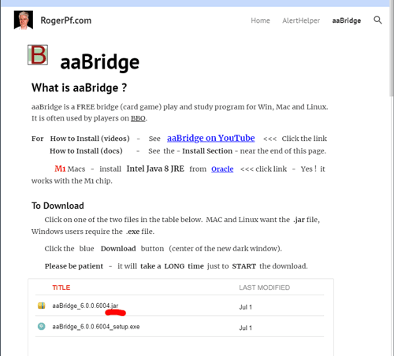

The page should look something like the image above.

Click the .jar link shown underlined in red above. IT WILL TAKE A LONG time. When it shows, click the - Download - option.

A file with a name like aaBridge_6.0.0.6006.jar
will now start to download. Again it will take a long time.
You many need to also click - Download anyway.
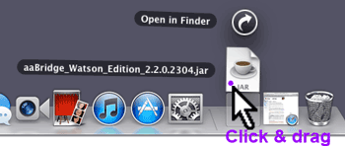
When it has finished downloading the download icon will bounce in the normal way and you can click on it (not shown). This will show all your downloaded files including the aaBridge and jar.

When you can see the .jar file click on it and drag it to a more convenient place. For example, on to the desktop.
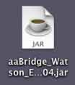
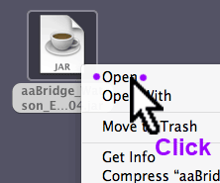
If you dbl-click on the .jar file now it may not work. What may happen is that you will get an error dialog telling you that the developer of aaBridge is unidentified.

In order to run aaBridge you needed to give it permission.

Click on the jar icon in the normal way that will display the mouse button menu. Try Ctrl and normal/dbl click

Java

Since Mavericks (OSX 10.9) Apple have stopped including 'built-in' Java in OSX.
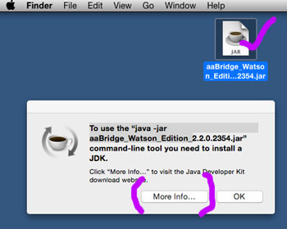

When you click on the aaBridge jar you may see a message like the one shown on the right.

Click the More Info. . . button

NOTE …

- The RJE will do fine for aaBridge you do NOT need the JDK

- You can just - Google Java (and get to the Oracle site)

- Click the red button (there may be more than one)

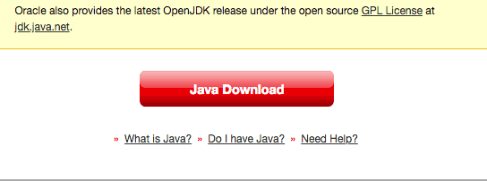

- Eventually you will end up downloading an Intel Mac file like

jre-8u311-macosx-x64.dmg version 8 is still correct.

M1 – Macs also want this Intel version 8 chip Java - Yes it works with M1 !

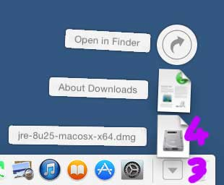
the .dmg at the end is important the tar.gz version is of no use to you.

Now open (3) the downloaded list of files as normal and (4) double click the
new JRE file and –

follow the normal instructions that will install Java on your system.

<end of page>
This is where the normal instructions resume (for systems that already have Java installed)

In order to run aaBridge you may needed to give it permission. Try double clicking first to check – if not then ...

Click on the jar icon in the normal way that will display the mouse button menu.

Click on Open in the menu as shown in the image.

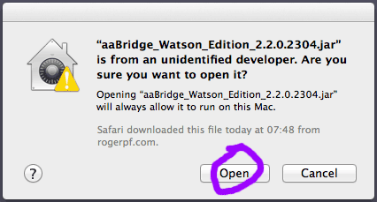
A dialog will be displayed.

This is basicaly asking if you trust aaBridge and its developer. This is sound question, you should not proceed unless you trust this software. This is true for any Software you are installing. Did you get this document from a reputable place? Has aaBridge been recommend to you? Do you know people who use it?

If you don't trust it don't go any further – only proceed if you have decided that you can trust the aaBridge program then –

Click the Open button from now dbl-clicking the .jar file will start aaBridge

<end of page>

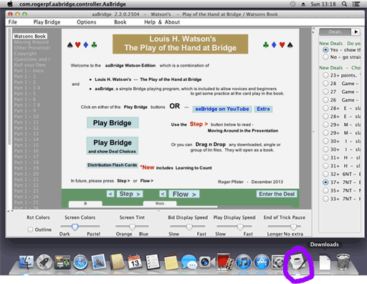
A Java cup will now appear on the main bar next to the downloads icon. The Java cup (ringed in purple in the large image) shows that the aaBridge app has started to run.

The very first time aaBridge starts it may take a while for the big window to appear.

If the aaBridge window has started hidden then you can make it appear by clicking on the Java Cup icon.

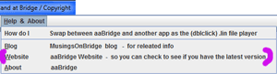
aaBridge is old fashioned in that the, check for new versions is done manually. Click on the menu item Help & About and click on the website option shown in the image with a purple markers.

Especially if you are a regular user it is worth checking every month or so.

If you are using aaBridge for the first time it you are advised to read the Click new Home button (TOP LEFT - not shown) and then click Flow >

and follow the New User Read me through its pages.

<end of page>

Drag & Drop to Play Bridge Movies
If you wish to use aaBridge to play Bridge Movies that you already have on your computer then open the folder containing the Bridge movies and drag & drop them on to an open aaBridge window like the one shown earlier.

A list of the Bridge movies you have just dragged and dropped will now appear at in the grey column on the left, you can click on the one you wish to play now.

How to play Bridge Movies from the Web

In Safari go to your favorite Bridge Site that has good Bridge Movies. Click on on a Bridge movie link.

The .lin file will download and the added to the Mac downloads in the normal way. Click on the download icon to open the curved list and drag the new lin file and drop it onto an open aaBridge window like the one shown earlier.

It will open in the same way as described above.

<end of page>

Hints on Using aaBridge

The navigation bar is the line of bumps, some of which may have characters on, which you can see at the bottom of the aaBridge screen.


You can click anywhere on this line and you will be jumped immediately to that part of that bridge movie. The bumps represent markup points that the author has put into the file to give it some structure. With aaBridge you are not limited to just the bumps you can click between the bumps and jump to that position.

When you are in a book with multiple chapters, each chapter is its own bridge movie, then you will see in the grey bar on your left the names of each chapter. Click on one to jump there.

You can also use the forward and backwards arrows on your keyboard. When you get to the end of a chapter then the forward arrow will move you to the next chapter. The same applies if you are going backwards.

Step and Flow buttons

In a bridge movie's you move forward to the next stopping point, often called a page, by clicking on the Step and Flow buttons. Additionally, if can't play all bidding is being shown to you then the flow button will show each card will bid being played a very short pause after each.

You can set the duration of the pauses by using the time the sliders at the bottom of the screen, grab and raise the horizontal divider.

You are strongly encouraged to go through all the options. They were put there for you. Grab the vertical divider on the right and move it left.

<end of document>

